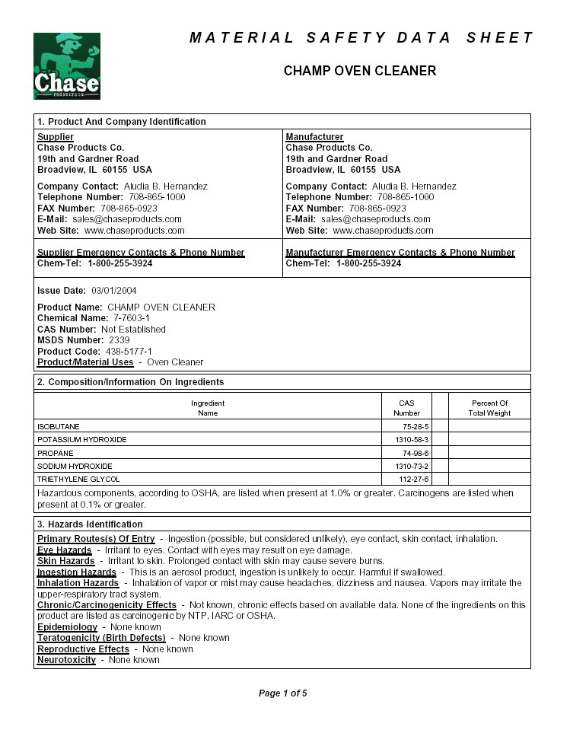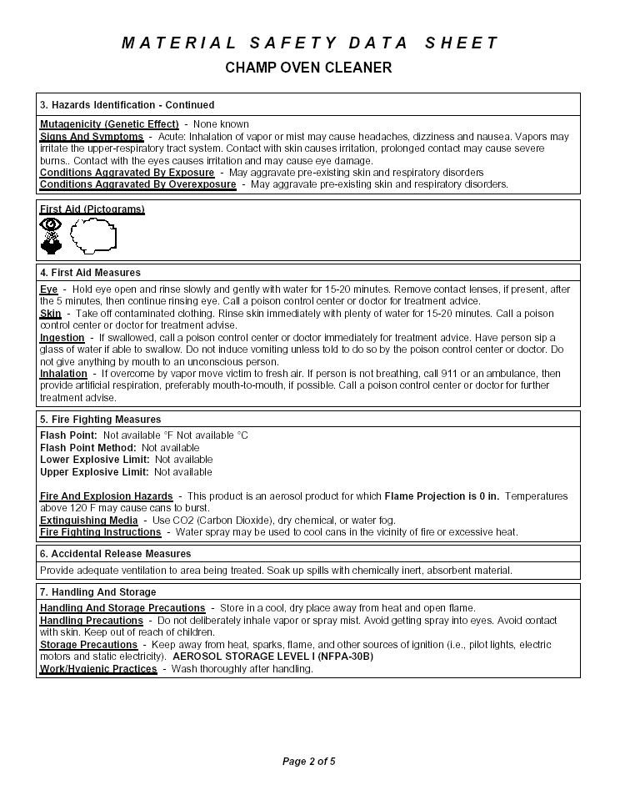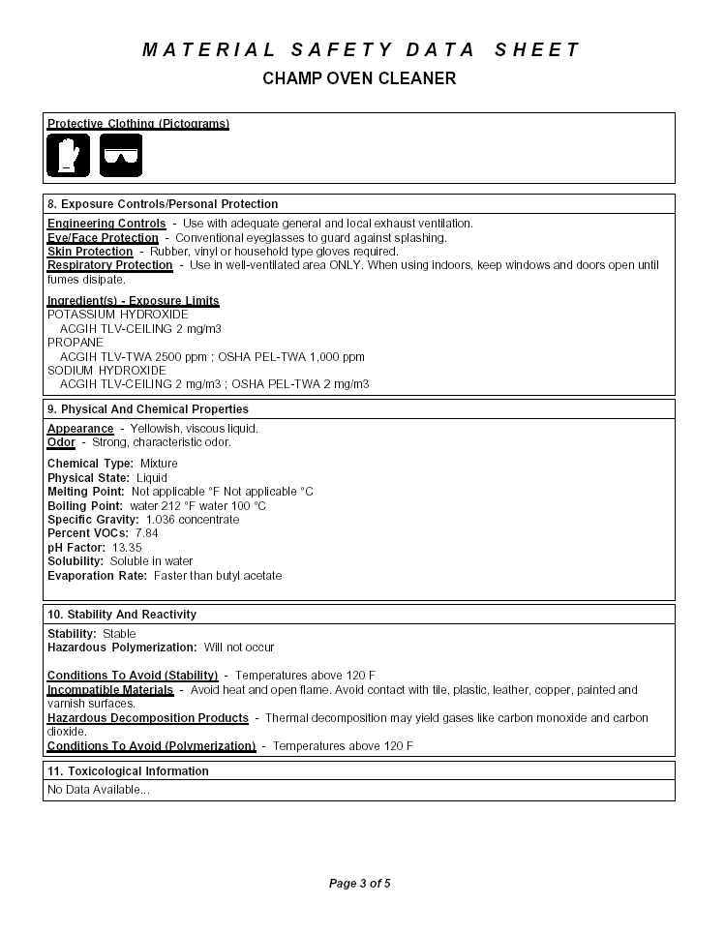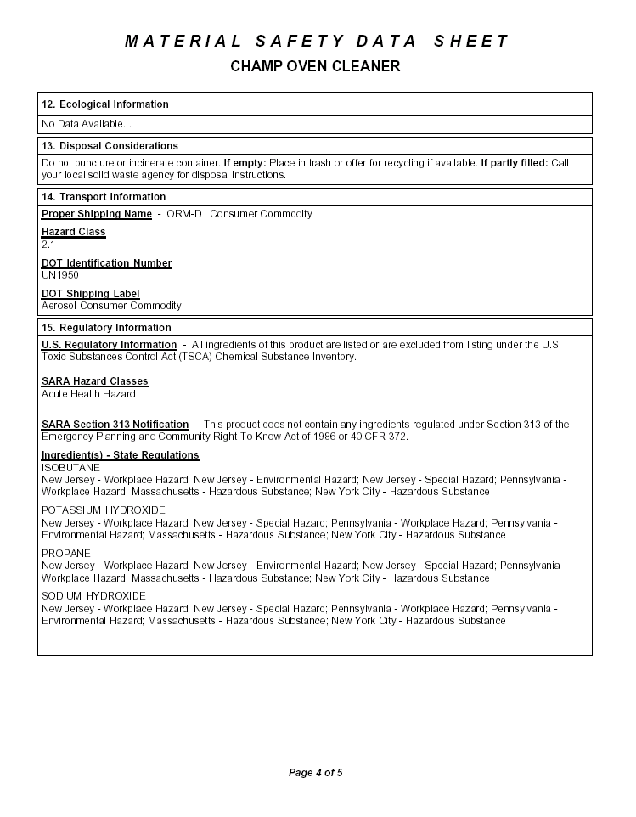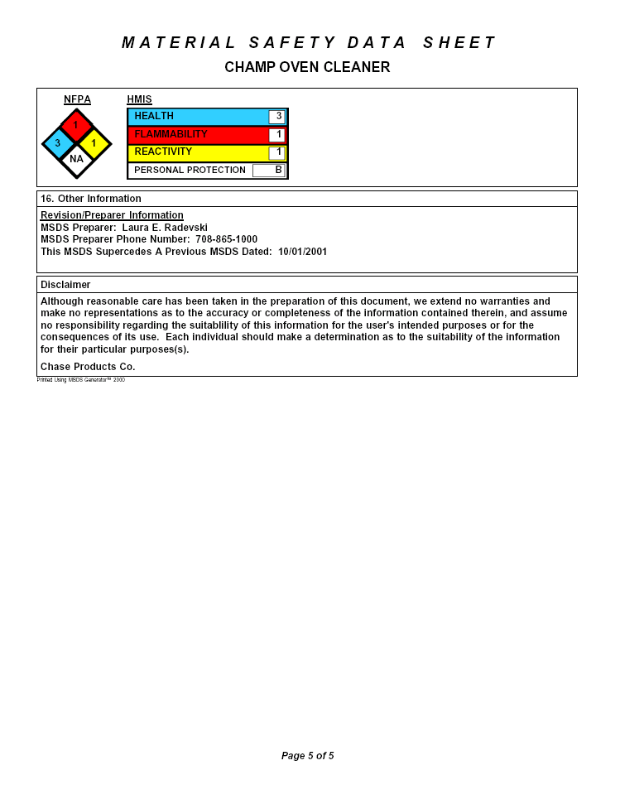

MATERIAL SAFETY DATA SHEET

CHAMPION OVEN CLEANER
Birsch Product #5177

Supplier
Birsch Industries
476 Viking Drive, Suite 102
Virginia Beach, VA 23452

Telephone Number: (757) 622-0355
Fax Number: (757) 625-7552
Web Site: www.birsch.com

MATERIAL SAFETY DATA SHEET

CHAMPION OVEN CLEANER
Birsch Product #5177

